Creative Brief
Title: Cosmetic Brands and Packaging Design Portfolio Website

Description:
My project will create a standalone, responsive portfolio website that highlights my work in cosmetic/ band packaging and brand identity. Designed as a polished visual showcase, the site will help potential employers, creative directors, and clients in the beauty industry or personal interest understand my skills, style, and approach.

Goals and objectives:
To build a professional, easy-to-navigate portfolio that shows how I bring cosmetic brands as well as others to life with visual storytelling, custom packaging layouts, and realistic 3D mockups. Also, to book jobs.

Audience:
• Primary audience: Creative directors, art directors, senior packaging designers, and hiring managers at design agencies, major beauty companies such as Sephora, Estée Lauder, and Coty, as well as independent beauty brands.
• Secondary audience: Freelance clients, founders of boutique cosmetics brands, and fellow designers.
• Demographics and values: Design professionals, those working in fashion and creative hubs like New York City. They enjoy polished high-end visuals, sustainable packaging structures, clear typography, accurate details, and a website that feels simple to explore.

Messaging and tone:
I want my website to feel sophisticated, modern, polished, editorial, and fun all while using a refined layout and detailed project presentations to show both my creative vision and skill in packaging design and print production. I really want to create a memorable and professional identity that will connect with creative directors, beauty brands and other businesses.

Assets and deliverables:
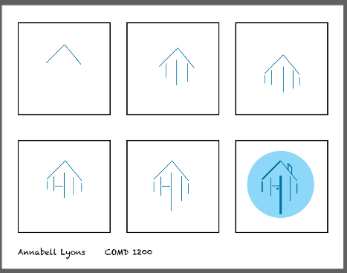
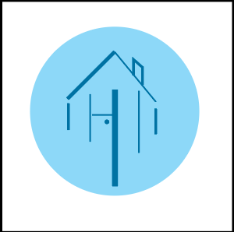
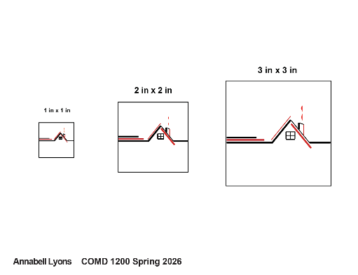
Showcase come of my work.

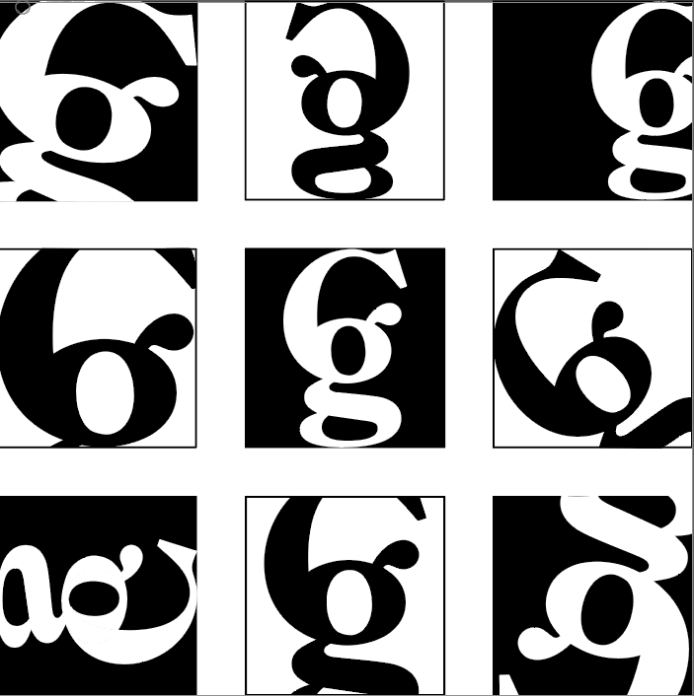
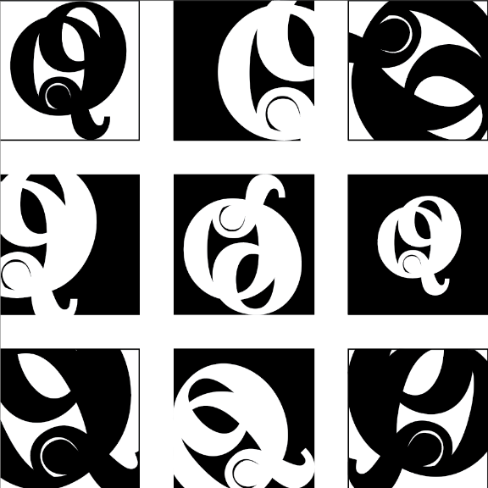

Stakeholders:
- Annabell Lyons — (Myself) Lead Designer, Developer & Project Owner

- Professor Sandra Lloyd (COMD 2451) — Primary Academic Evaluator & Design Approver

Budget:
$0.00.

Timeline:
- December 18, 2026: Final COMD 2451 portfolio site deployment, code submission, and final presentation.
- December 11, 2026 (Week 14): Complete final HTML/CSS code integration, perform cross-browser/responsive testing.
- November 20, 2026 (Week 12): Complete high-fidelity visual design mockups, finalize CSS style guides (color palette, typography, spacing), and prepare image assets.
- October 23, 2026 (Week 8): Conduct midterm project review, refine responsive navigation, and complete low-to-mid fidelity interactive prototypes.
- September 30, 2026 (Week 3 / Current): Finalize feature list prioritization select artwork I want to highlight and submit low-fidelity layout sketches.
- September 16, 2026 (Week 1): Project start, review portfolio website requirements, and begin initial HTML/CSS structural setup.

Distribution process:
The website will be published live using custom domain or portfolio URL. It will be going through direct application links on LinkedIn, included in resume submissions to design agencies, linked within my social media bios such as Instagram and fakebook.

